Section 1.8: The Normal Distribution

Recall in Section 1.4, we looked at graphs of quantitative data. The histogram was a graph of the frequency table of data. We spoke of several shapes for histograms in section 1.4.

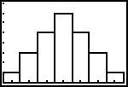 | 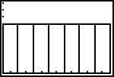 | 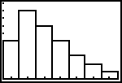 | 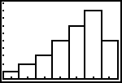
bell-shaped  (symmetric) | uniform  (symmetric) | right-skewed  (not symmetric) | left-skewed  (not symmetric)

We often encounter quantitative data that has a bell-shaped histogram. The bell-shaped graph, when it occurs, is of particular importance—it is often called a Normal Distribution.

Let’s look at example of a quantitative data where we make a histogram that is bell-shaped.

Example One way to measure intelligence is with an IQ score. The tables below contains 50 IQ scores, and the following table has the frequency and relative frequencies for the sample.

IQ Scores
78 | 92 | 96 | 100 | 67 | 105 | 109 | 75 | 127 | 111
93 | 114 | 82 | 100 | 125 | 67 | 94 | 74 | 81 | 98
102 | 108 | 81 | 96 | 103 | 91 | 90 | 96 | 86 | 92
84 | 92 | 90 | 103 | 115 | 93 | 85 | 116 | 87 | 106
85 | 88 | 106 | 104 | 102 | 98 | 116 | 107 | 102 | 89

Frequency and Relative Frequency for IQ Scores
IQ | Frequency | Relative Frequency
63.5 – 70.5 | 2 | 0.04 or 4%
70.5 – 77.5 | 2 | 0.04 or 4%
77.5 – 84.5 | 5 | 0.10 or 10%
84.5 – 91.5 | 9 | 0.18 or 18%
91.5 – 98.5 | 11 | 0.22 or 22%
98.5 – 105.5 | 9 | 0.18 or 18%
105.5 – 112.5 | 6 | 0.12 or 12%
112.5 – 119.5 | 4 | 0.08 or 8%
119.5 – 126.5 | 1 | 0.02 or 2%
126.5 – 133.5 | 1 | 0.02 or 2%
Total | 50 | 1.00 or 100%
The histogram and corresponding relative frequencies are below.

Relative Frequency Histogram for IQ
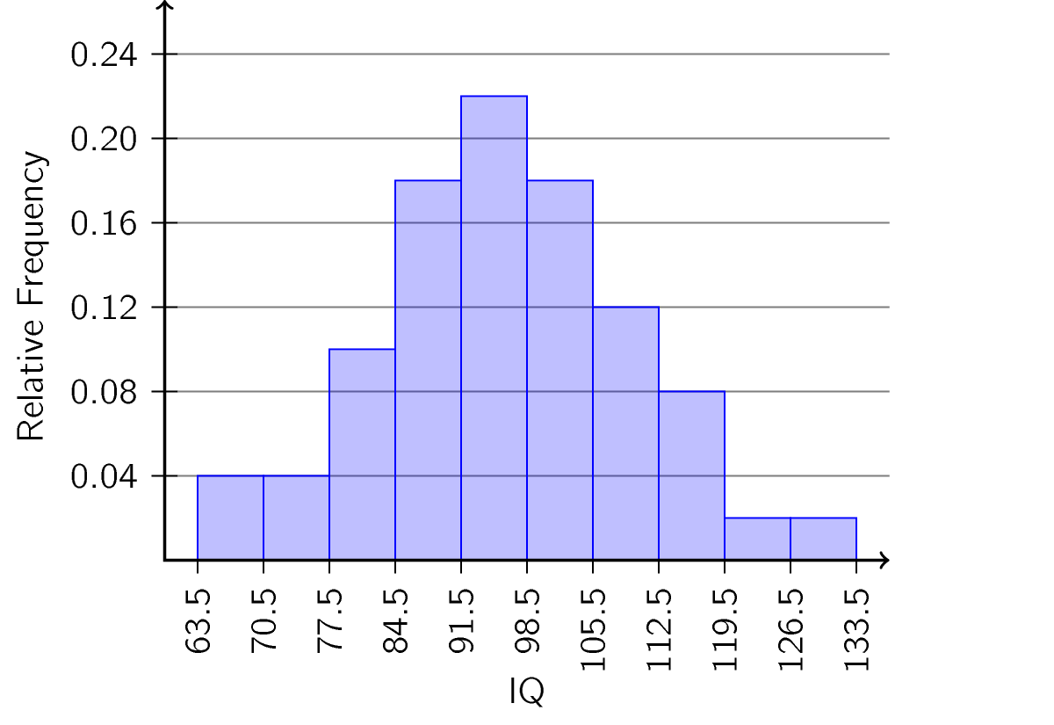
Relative Frequency Table
IQ | Relative Frequency
63.5 – 70.5 | 0.04
70.5 – 77.5 | 0.04
77.5 – 84.5 | 0.10
84.5 – 91.5 | 0.18
91.5 – 98.5 | 0.22
98.5 – 105.5 | 0.18
105.5 – 112.5 | 0.12
112.5 – 119.5 | 0.08
119.5 – 126.5 | 0.02
126.5 – 133.5 | 0.02
Total | 1.00

Let’s make some important remarks here:
- The total of the relative frequencies is 1 or 100%.
- The most frequently occurring IQ class is 91.5—98.5. In fact, the Median IQ of 96 and the Mean IQ = 96.02 both are within the range of 91.5 to 98.5. Therefore, the mean, median and mode of the histogram are all roughly the same.
- The relative frequency of each class represents the chance or likelihood that any randomly chosen person in the sample has an IQ in that class.
- Proportionally, the area of any one rectangle in the histogram with respect to the total area represents the chance or likelihood that any randomly chosen person in the sample has an IQ in that class.
- We will use the term probability as being equivalent to the chance or likelihood of an “event” occurring. In our case, the event will be the value of our random variable X. In our example, X = I.Q. of a random person in our sample of 50.

- The probability of an IQ being between 70.5 and 77.5 is ______ or ______%. This is denoted as

- We can calculate $P(X>105.5)$ by adding up four probabilities:
$P\left(\text{______}<X<\text{______}\right)=$ ______
$P\left(\text{______}<X<\text{______}\right)=$ ______
$P\left(\text{______}<X<\text{______}\right)=$ ______
$P\left(\text{______}<X<\text{______}\right)=$ ______
So we find $P\left(X>105.5\right)=$

Graphs of the Normal Distribution
Many real-life problems produce a histogram that is symmetric, unimodal, and bell-shaped. For example: height, blood pressure, and cholesterol level. However, not every bell-shaped curve is a normal curve. In a normal curve, there is a specific relationship between its “height” and its “width.”

Normal curves can be tall and skinny or they can be short and fat. They are all symmetric, unimodal, and centered at µ, the population mean. Figure #3.8.4 shows two different normal curves drawn on the same scale. Both have $μ=100$ but the one on the left has a standard deviation of 10 and the one on the right has a standard deviation of 5. Notice that the larger standard deviation makes the graph wider (more spread out) and shorter.

Different Normal Distribution Graphs
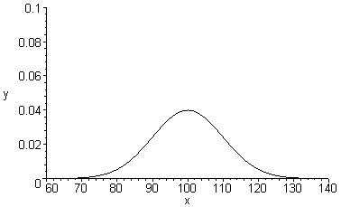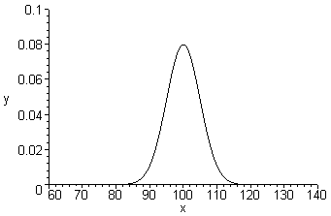

All normal curves have common features. These are detailed in the figure below.

Typical Graph of a Normal Curve
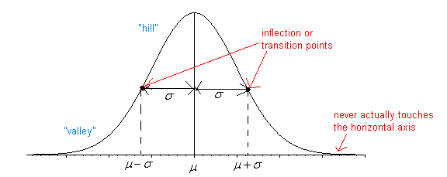
- The center, or the highest point, is at the population mean, µ.
- The transition points (inflection points) are the places where the curve changes from a “hill” to a “valley”. The distance from the mean to the transition point is one standard deviation, σ.
- The area under the whole curve is exactly 1. Therefore, the area under the half below or above the mean is 0.5.

Note: When working with a normal distribution, we think of the mean µ
and the _______________ standard deviation σ.

Example Properties of the Normal Curve
Use the graph below of the normal distribution of some random variable X to identify the values of $μ and σ$

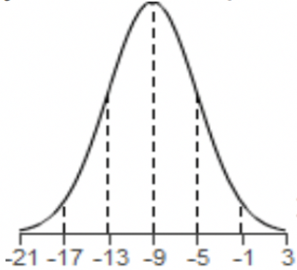

Solution:
The middle point of the graph is ______ so $μ=$ ______
The inflection (turning) points of the graph are at ______ and ______, so we can find $σ$ by calculating:

We get $σ=$ ______

The equation that creates this curve is $f\left(x\right)=\frac{1}{σ\sqrt{2π}}e^{-\frac{1}{2}{\left(\frac{x-μ}{σ}\right)}^{2}}$

In many quantitative variables (like height, weight, time, volume, temperature, distance, speed, etc.) we assume that the random variable, X, can take on an infinite number of values. For example, a time we measure as 3 seconds might be 3.001 seconds or 2.999 seconds, and we would never know. For this reason, instead of looking at the probability of X being a single value, we are interested in finding the probability of X occurring in the range between a and b. We express this as either $P\left(a≤x≤b\right)$ or $P\left(a<x<b\right)$: because the variable can take on infinitely many values in a tiny range, it doesn’t matter whether we use ≤ or just < here.

Calculus tells us that to find this we find the area under the curve above the interval from a to b.

$P\left(a≤X≤b\right)=P(a<X<b)$ is the area under the curve above the interval from a to b.

Finding Probabilities for the Normal Distribution

First, let’s consider a way of approximating the area under a normal curve. This is something that we can fairly easily calculate by hand, and so it gives us a “reality check” on the answers we will get with technology.

The Empirical Rule
The Empirical Rule gives us a quick and easy method of calculating the probability of some event, assuming the variable is normally distributed.

Empirical Rule
If X is normally distributed with a mean of µ and a standard deviation of σ, we have:
- $P\left(μ-σ<x<μ+σ\right)≈68\%$
- $P\left(μ-2σ<x<μ+2σ\right)≈95\%$
- $P\left(μ-3σ<x<μ+3σ\right)≈99.7\%$
These probabilities, along with the fact that the normal distribution are symmetric, give us the following areas under the graph of a normal distribution.
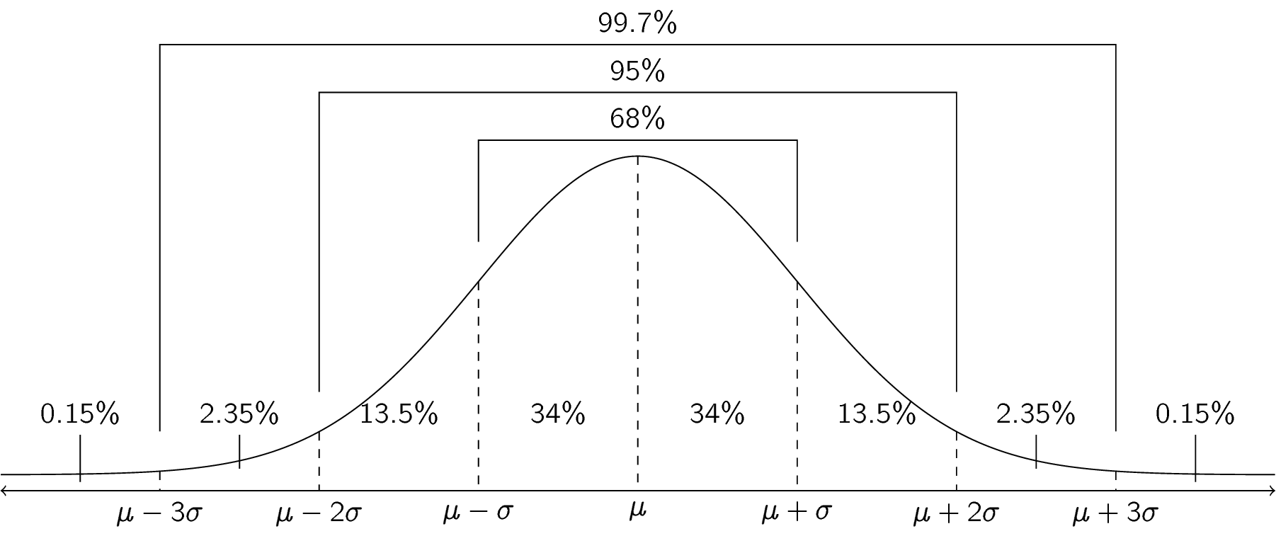

Let’s use this diagram, along with the Empirical rule, to estimate some probabilities for a normally distributed variable.

Example Finding Approximate Probabilities
Heights of men in the United States are approximately normally distributed with a mean of approximately 69 inches and a standard deviation of approximately 3 inches.
Solution
It can be useful to first label a graph representing the Empirical Rule with the mean and standard deviation for this population. Then we can find the probabilities given above by finding the areas of appropriate regions under the graph:
- State the individual, variable, type of variable and random variable and list the givens with the correct symbols.
Individual:
Variable:
______ = 69 inches ______ = 3 inches
- Use the Empirical Rule to estimate the probability that a US man has a height between 69 and 72 inches.
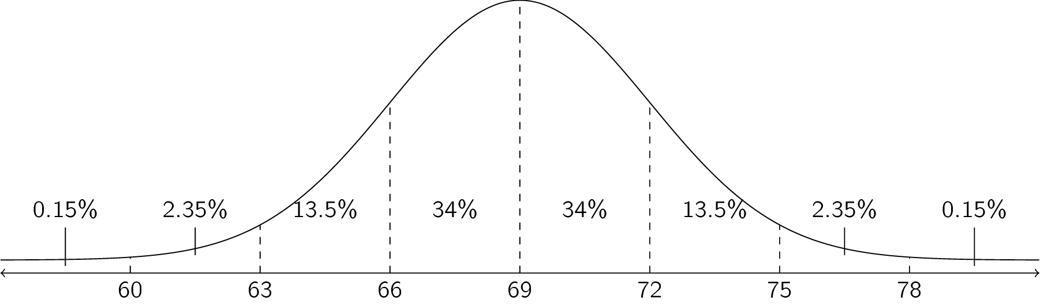
$$P\left(\text{______}<X<\text{______}\right)=\text{________\%}$$
- Use the Empirical Rule to estimate the probability that a US man has a height between 66 and 75 inches.

$$P\left(\text{______}<X<\text{______}\right)=________+________+________=\text{________\%}$$

- Use the Empirical Rule to estimate the probability that a US man has a height less than 63 inches.

$$P\left(X<\text{______}\right)=________+________=\text{________\%}$$
- Use the Empirical Rule to estimate the probability that a US man has a height greater than 66 inches.

$$P\left(X>\text{______}\right)=_______+_______+_______+_______+_______=\text{_______\%}$$

This method has three major disadvantages:
- It only works for a _____________________ number of standard deviations.
- It can be time consuming and error prone, especially when the mean and standard deviation are decimals.
- These percentages (68%, 95%, and 99.7%) are approximate, rounded to make them easy to remember.

For more realistic questions, we will use technology.

Aside – Scientific Notation
In order to make sense of the way that we will work with normal distributions on the calculator, we need to understand scientific notation.

Scientific notation is used to indicate very large or very small numbers, so that we don’t need to keep track of lots of zeros. To translate a number given in scientific notation into a number given in regular decimal notation, use the following steps.
- Copy the part of the number before the E (or before the $×$ sign in regular scientific notation.
- If the number after the E in scientific notation is positive:
  - Add zeros until there are at least that many digits after the decimal point.
  - Move the decimal point that number of places to the right.
- If the number after the E in scientific notation is negative:
  - Add that number of zeros before the first digit (ignoring the negative sign)
  - Move the decimal point that many places to the left (ignoring the negative sign)
In scientific notation, the number before the E or the $×$ sign always has one nonzero digit (that is, one digit 1-9) before the decimal point.

Example Translating Scientific Notation
Fill in the table below.
Calculator | Scientific Notation | Decimal Notation
4.1E6
3.75E-4
 | $$6.41×{10}^{8}$$
 | $$-5.1×{10}^{-5}$$
 |  | 18,730,000,000,000
 |  | 0.00000422
Solution:

- 4.1E6

- 3.75E-4

- $6.41×{10}^{8}$

- $-5.1×{10}^{-5}$

- 18,730,000,000,000

- 0.00000422

Computing Probabilities Using Technology
We are now ready to compute probabilities for the normal distribution using technology.

TECHNOLOGY: COMPUTING PROBABILITIES FOR NORMAL RVs
Using your TI84:
- First push y to open the Distribution menu
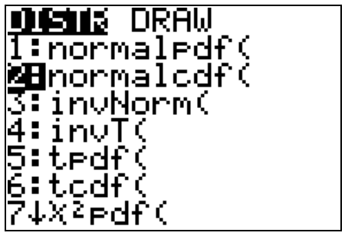
- Push Á to pick 2:normalcdf(. You will then either have a screen like the one of the left with a blinking cursor waiting for you to enter the lower endpoint of the interval, the upper endpoint of the interval, the mean, and the standard deviation OR you have a screen that looks like the one on the right.
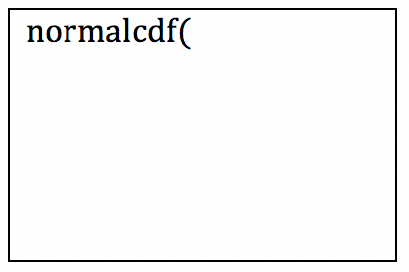 or 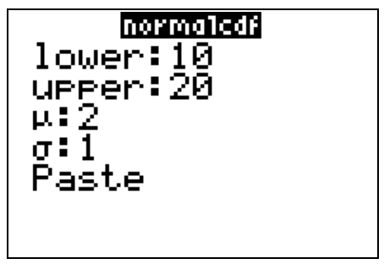
- If there is no lower limit, enter -1E99 by pressing ÌÀy¢®® to represent “the largest negative number possible” to the calculator.
- If there is no upper limit, enter 1E99 by pressing Ày¢®® to represent “the largest positive number possible” to the calculator.
- Then highlight “Paste” and push Í.

When entered correctly, the screen on the left will show the following for the values shown in the screen on the right:
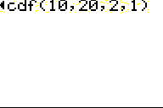

In the above instructions:
- -1E99 means $-1×{10}^{99}$, which is -1 followed by ______ zeros.
- 1E99 means $1×{10}^{99}$, which is 1 followed by ______ zeros.

Example Normal Distribution
The length of a human pregnancy is normally distributed with a mean of 272 days with a standard deviation of 9 days (Bhat & Kushtagi, 2006).

- State the individual, variable, type of variable and random variable X and list the givens with the correct symbols.

Solution:
Individual:
Variable:
______ = 272 days ______ = 9 days

- Find the probability of a pregnancy lasting more than 280 days.

Solution:
We can still understand this as finding the area under a normal curve, but now instead of the Empirical Rule probabilities, we’ll use the calculator.
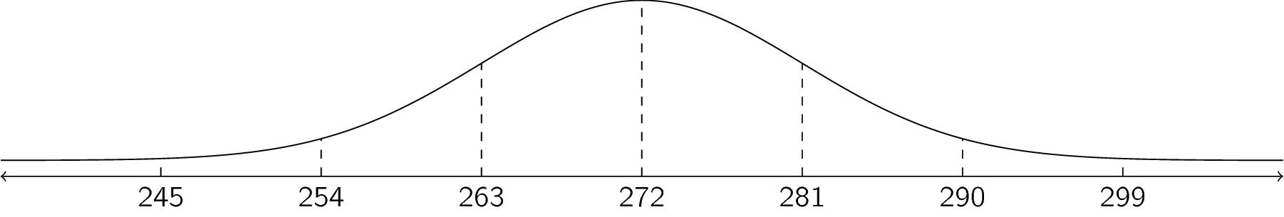
We enter this on the calculator as follows. (Note: Your calculator may scroll a single line instead of wrapping the command to the next line. This is normal; the screen shot is set not to scroll so you can see the whole line.)
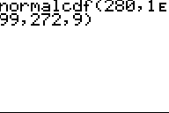 or 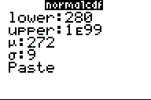
We entered 1E99 as the upper limit because

Either version gives us the output:
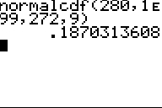
$$P\left(X>280\right)=\text{normalcdf}(280,1\text{E}99,272,9)≈0.1870$$
Interpret:

- Find the probability of a pregnancy lasting less than 250 days.

Solution:

We enter this on the calculator as follows.
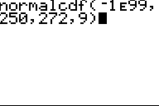 or 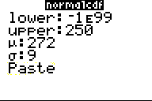
We entered -1E99 as the lower limit because

Either version gives us the output:
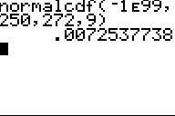
$$P\left(X<250\right)=\text{normalcdf}(-1\text{E}99,250,272,9)≈0.0073$$
Interpret:

- Find the probability that a pregnancy lasts between 265 and 280 days.

Solution:
This time, we enter the problem on the calculator with a lower limit of ______ and an upper limit of ______, which gives us
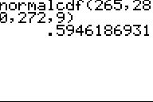
$$P\left(265<X<280\right)=\text{normalcdf}(265,280,272,9)≈0.5946$$
Interpret:

Example Normal Distribution
The mean mathematics SAT score in 2012 was 514 with a standard deviation of 117 ("Total group profile," 2012). Assume the mathematics SAT score is normally distributed.

- State the individual, variable, type of variable and random variable and list the givens with the correct symbols.

Solution:
Individual:
Variable:
______ = 514 ______ = 117

- Find the probability that a person has a mathematics SAT score over 700.

Solution:
We enter this on the calculator with lower limit _____ and upper limit _____

$$P(\text{_______________________})≈____________=__________\%$$
Interpret:

- Find the probability that a person has a mathematics SAT score of less than 400.

Solution:
We enter this on the calculator with lower limit _____ and upper limit _____

$$P(\text{_______________________})≈____________=__________\%$$
Interpret:

- Find the probability that a person has a mathematics SAT score between a 500 and a 650.

Solution:
We enter this on the calculator with lower limit _____ and upper limit _____

$$P(\text{_______________________})≈____________=__________\%$$
Interpret:

